

**Join Youth Ministry Serving at   
St. Joseph’s Foster Home**

**Who we will serve:** children aged 0-10 who are in foster   
 care and away from their families.

**Who can go:** Students who will be in 7th-12th grade for   
 2017-2018 school year   
 (current 6th graders welcome!)

**When:** July 29, 2017 Departure and Return TBD

**Where:** St. Joseph’s Carmelite Home, East Chicago, Indiana   
 A bus will leave from OLP. We will stop for lunch.

**What:** We will go to the foster home and in partnership with   
 “Your Children’s Bookshelf” we will provide books   
 for the children of the home, spend time with children,   
 get to know them, and help the sisters out.

Diaper and Book Drive!

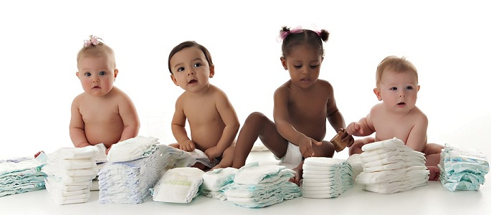



What: Diaper and book drive   
 weekend to collect diapers,   
 baby supplies, and books for   
 St. Joseph’s Foster Home.  
  
Who: 6th -12th grade volunteers to   
 collect diapers, supplies, and   
 books after all Masses.

Where: OLP Church

When: Weekend TBD

Contact: Rissa Loucks 630-487-1507

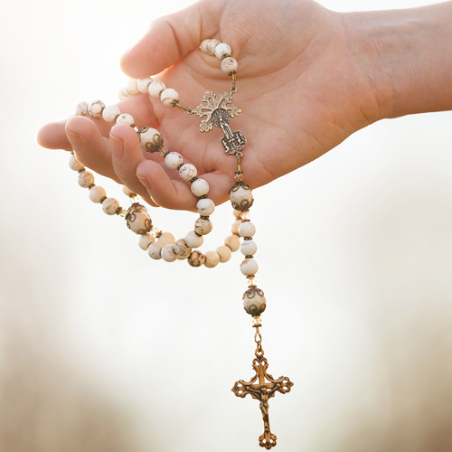

**Living Rosary**

Saturday May 13th -7:00 pm

Join Youth Ministry as we honor the Blessed Mother and pray the rosary together with our Parish

Carnival

To Support Edmundite Missions who serve the poor in   
Southern U.S.